Wash Me App Project Proposal

Part Three: Design

Team members

Add your names here as a list

Wash Me App Proposal

*<<Copy/paste from Part 1 content in these sections>>*

# Overview

**Tell the reader the purpose of Part 3** of the proposal as it relates to the double diamond interaction design process. What are the major sections of this proposal and why are they necessary? Refer to the lectures, reading and videos.

Write in paragraphs -in not bullet lists. I use bullet points to help you think about the content.

Add your content after the section comments. Delete the purple comments. Marks will be lost for undeleted comments.

Your stuff goes here…

# Background

<Which user research methods were used to learn about the current system, why it is a problem and what the goal state might look like?>

Describe the initial problem state>.

* What is the current system in place?
* What problem does it solve?
* Who is it designed for?
* Who might be potential users of the **new** system? Why?

Your stuff goes here…

# Problem

<Describe the problem space –it will be similar to the Background section but with more detail.

* What is the essential, core problem? Refer specifically to the UX Hierarch of Needs. If a level is not being met then the level above are also affected.
* Describe 2 – 3 symptoms of the problem from the **Owner/Operator’s** perspective.
* How are each of these symptoms impacting the goal of user?
* For example, “The problem is the UI does not follow standard navigation rules . The site navigation is located under the Help menu. Symptoms of this unconventional layout include: Confusion. Users don’t know how to navigate the site. Frustration, users can’t find what they are looking for. Low conversion rate, users abandon the site because they can’t figure out how it works. Most apps have the site navigation along the top or level panel.”
* Describe 2 – 3 symptoms of the problem from the **customer’s** perspective.
* How are each of these symptoms impacting the goal of this user?
* Be very clear about what aspects of the system are symptoms and how they negatively affect the users’ goals, needs and wants.
* Give specific examples, **include images from similar products>**

Your stuff goes here…

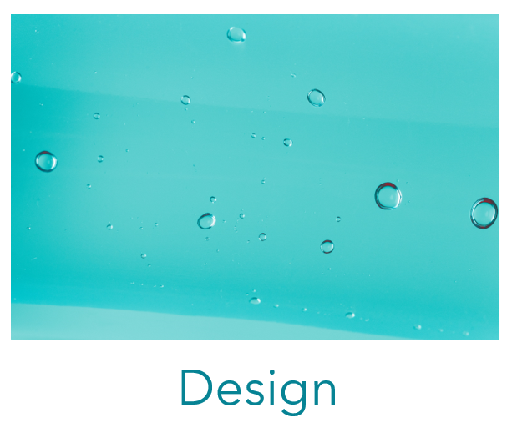

# Task Flow

<**Explain** what a task flow diagram is and how is it useful in the design process. Show all the necessary screens from the “trigger” to the post condition. **Include at least 1 alternate flow**. Insert your diagram **after** your explanation>

# Balsamiq wireframe

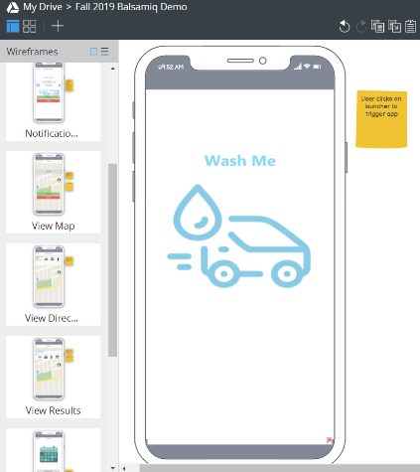<Add a screenshot of the project screen that shows the main viewport and wireframes panel in this section>

A wireframe is a low-fidelity way to show the design. It is a graphical representation of an app or websites that allows designers to understand the most essential elements and the content easily. This wireframe demonstrated the task flow of customer making an appointment. This cleared the actions described in words and gives designer an example of structure, layout and overall direction of the flows. However the wireframe has the limitations, such as it cannot show the complex interactions, limited usefulness for usability and don’t show the visual design. Therefore, wireframe is good for initial setups.

# Hi fidelity Prototype

<Insert the link to your **published** hi fidelity prototype in this section. See instructions [here](https://youtu.be/V47zFgWpFFw). Alternate forms of submission will not be marked>

# Screencast walkthrough

< Briefly explain what a screemcast walkthrough is and its purpose. **MP4** must be uploaded to Blackboard. Add the **Adobe Spark URL** in the textbox section in Blackboard>

# Design Patterns

< Fully describe the design patterns used in your screen designs (name, description, problem addressed, solution, link to an example). Where are they located in your prototype?>

# Design Systems section

<The design system is a visual dictionary of the components used in your design. It ensures consistent look and feel. Include visual examples of each component

Include the following components in your design system section.

* Brand colors – hex codes and transparencies
* Fonts for labels and text, size and hex codes for different states
* Buttons -primary, secondary size and hex codes for different states
* Navigation (Tabs? Grid? Menu?)
* Logo – original, branded and represents purpose of the app/website

Do not use Indigo’s default blue or the hex codes from Lab 8. Be original.>

# Summary

< Bring the project to a close. Remind the user of the current system and its problem(s) and symptoms. How did you learn more about the problem? What methods did you use to identify the system’s requirements? Why did you create prototypes? What are some of the features in your design that fix the **symptoms** identified from the beginning? What would be the next step in the development process? The summary should be a **minimum of ½ page in length**.>

# Credits

*<<Identify and briefly describe each member’s contribution to this assignment. Significant disparities may be reflected in the member’s mark.>>*